
CUSTOMER CHURN & RETENTION ANALYTICS
Understanding churn drivers, customer risk and retention opportunity
━━━━━━━━━━
16.84% overall churn | ₹152.03K value associated with churn | 41.86% new-customer churn
ANALYTICS REPORT · E-COMMERCE CUSTOMER BASE · 5,630 RECORDS
Prepared 31 August 2026 · Python · MySQL · Power BI
Data Analytics Portfolio Project

Contents
1. Executive Summary
2. Business Problem & Objectives
3. Data & Analytical Framework
4. Data Quality & Preparation
5. Overall Churn Landscape
6. Churn Driver — Customer Lifecycle
7. Churn Driver — Customer Experience
8. Other Churn Signals
9. Customer Value & Risk Segmentation
10. Business Impact — Value at Risk
11. Retention Strategy & Action Plan
12. Conclusions & Recommendations
13. Limitations & Guardrails
Appendix A — Technical Implementation
Appendix B — Figure & Data Source Index

1. Executive Summary
This report presents the findings of an end-to-end customer churn and retention analysis performed on 5,630 e-commerce customer records. The analysis moves from measurement (how much churn exists) to diagnosis (where and with whom churn concentrates) to action (where retention investment should begin). All financial figures are derived from CashbackAmount and are therefore reported as a customer-value proxy, not as actual company revenue.
KPI | Value | Interpretation
Total customers | 5,630 | Full analysed customer base
Retained customers | 4,682 (83.16%) | Active base
Churned customers | 948 (16.84%) | Overall churn rate 16.84%
Total customer-value proxy | ₹997.77K | CashbackAmount-derived, all customers
Value associated with churn | ₹152.03K (15.24%) | Customer-value exposure from churned customers
Complaint churn rate | 31.67% vs 10.93% (no complaint) | ≈2.9× higher observed churn with complaints
New-customer churn (0–3m) | 41.86% | Highest observed lifecycle risk; 653 of 948 churned
Loyal-customer churn (25m+) | 0.00% | No observed churn beyond 25 months
Avg tenure — churned vs retained | 3.86 vs 11.40 months | 7.54-month tenure gap between outcomes

Key findings
- Churn is concentrated, not uniform: the 0–3 month lifecycle stage churns at 41.86% while all later stages remain below 10% (Loyal 0.00%).
- Complaint behaviour is strongly associated with churn: 31.67% vs 10.93% — an observed gap of ≈2.9×.
- Churn converts into measurable value exposure: 15.24% of the total customer-value proxy (₹152.03K of ₹997.77K) is associated with churned customers.
- Value-aware segmentation works: churn falls from 25.07% in the lowest value quartile to 10.95% in the highest; risk-level segmentation isolates a critical pool churning at 60.2%.
- Retention is actionable: a 5-percentage-point churn reduction would protect an estimated ₹7.60K of customer-value proxy; 10 points would protect ₹15.20K.
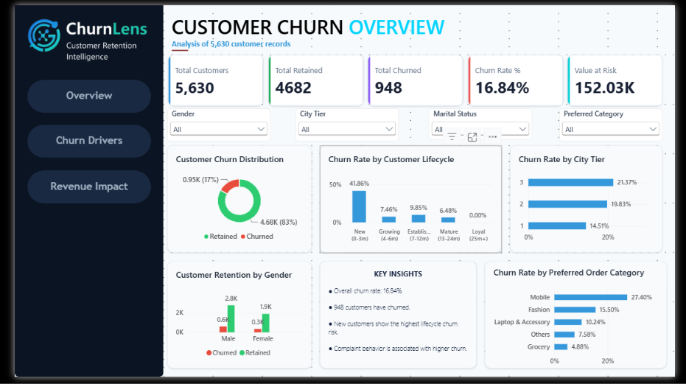
Figure 1 · ChurnLens overview dashboard — executive KPIs and headline distributions.
Recommended focus: prevent early churn → resolve complaints faster → protect high-risk customer value.

2. Business Problem & Objectives

2.1 Business problem
Customer churn reduces the future value of the customer base. Management needs to know not only how many customers churn, but why they churn, who is most exposed, and where retention effort should be prioritized. An aggregate churn rate of 16.84% is meaningful, but by itself it does not identify where intervention should begin.

2.2 Analytical objectives
# | Objective | Question answered
01 | Quantify churn | How much churn exists in the customer base?
02 | Identify churn drivers | Which lifecycle stages, behaviors and experiences associate with churn?
03 | Segment customers | How does churn vary by lifecycle, demographics and customer value?
04 | Quantify value exposure | How much customer-value proxy is associated with churn?
05 | Prioritize retention | Where should retention investment start, and what should be monitored?

2.3 Intended audience & use
Prepared for senior management and operating teams — Customer Success, CRM, Retention and Marketing. Findings are presented as observed associations to support prioritization decisions; no causal claims or guaranteed outcomes are made.

3. Data & Analytical Framework

3.1 Dataset
A single customer-level e-commerce dataset of 5,630 records and 20 attributes supports the complete analysis. Each record carries profile, engagement, experience, lifecycle and value dimensions, plus a binary churn outcome.
Data domain | Attributes | Analytical role
Customer profile | Gender, marital status, city tier | Segmentation context
Engagement | App usage hours, devices registered, login device, order behaviour | Behavioral churn signals
Experience | Satisfaction score, complaints, warehouse-to-home distance | Service-quality signals
Lifecycle | Tenure (months), days since last order | Primary risk dimension
Value | Order count, cashback amount (value proxy), order-growth indicators | Exposure & prioritization
Outcome | Churn (1/0) | Target variable

3.2 Methodology & toolchain
The workflow converts raw records into progressively more decision-ready information:
- Python (Pandas, NumPy, Matplotlib/Seaborn): profiling, cleaning, imputation, EDA, cohort & RFM analysis.
- MySQL: analytical storage and business querying — aggregations, CASE WHEN, CTEs, joins, window functions (RANK, NTILE, LAG).
- Power BI: three interactive dashboards (Overview, Churn Drivers, Revenue Impact) for executive consumption.
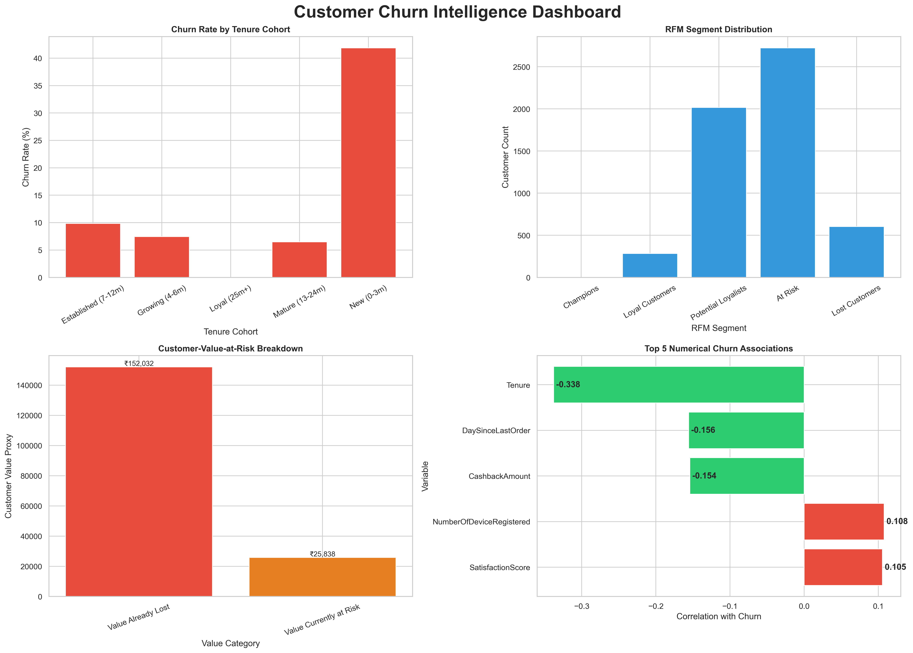
Figure 2 · Customer churn intelligence dashboard — lifecycle, RFM distribution, value-at-risk and top numerical associations.

4. Data Quality & Preparation
Data quality was addressed before any business analysis. The preparation pipeline applied: raw-data ingestion → quality checks → duplicate detection (CustomerID and exact-record) → missing-value treatment → type/category standardization → validation → clean analytical dataset (5,630 rows).

4.1 Missing-value profile (raw data)
Column | Missing values | Treatment
DaySinceLastOrder | 307 | Median-based imputation
OrderAmountHikeFromlastYear | 265 | Profiled / standardization
Tenure | 264 | Profiled / validated
OrderCount | 258 | Median-based imputation
CouponUsed | 256 | Profiled / standardization
HourSpendOnApp | 255 | Profiled / standardization
WarehouseToHome | 251 | Profiled / validated

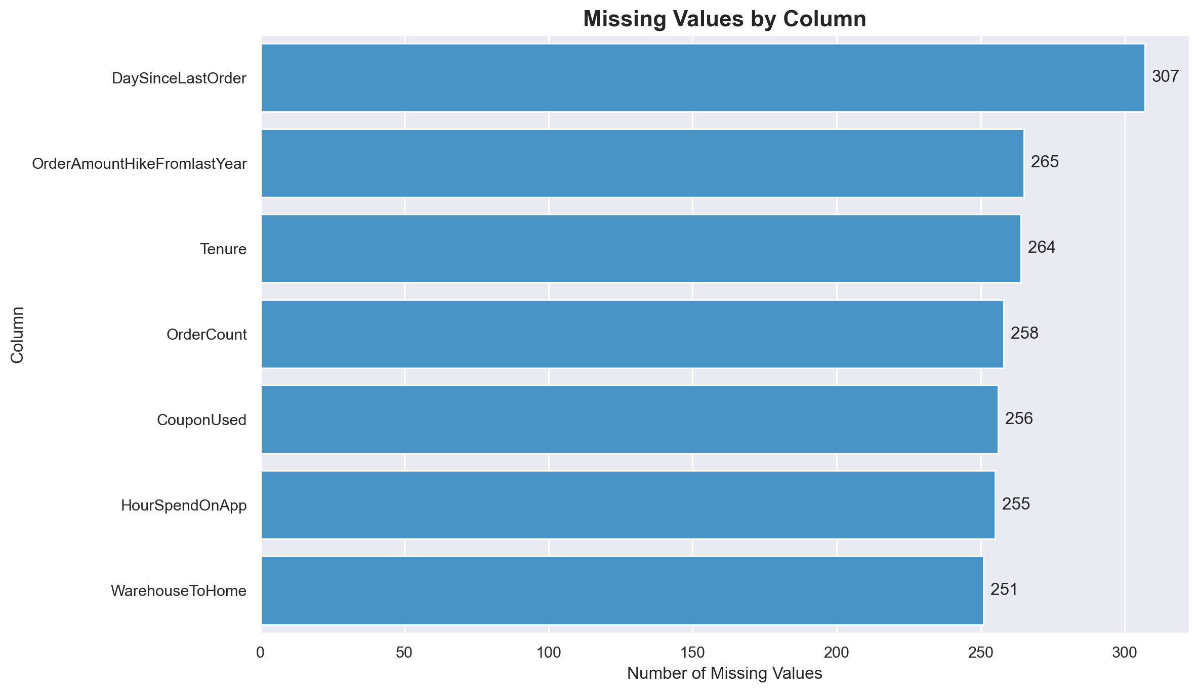
Figure 3 · Missing values by column in the raw dataset.

4.2 Quality controls
- Null-value profiling per column; duplicate CustomerID detection; exact duplicate record detection.
- Numeric range validation and categorical consistency checks.
- Median-based imputation for OrderCount and DaySinceLastOrder (per the SQL cleaning log).
- Final row-count validation: 5,630 customer records carried into analysis.

5. Overall Churn Landscape
Of 5,630 customers, 948 (16.84%) have churned and 4,682 (83.16%) are retained — roughly 1 in 6 customers. The distribution is mildly imbalanced, typical for churn problems, and justifies segment-level analysis rather than reliance on the aggregate rate.
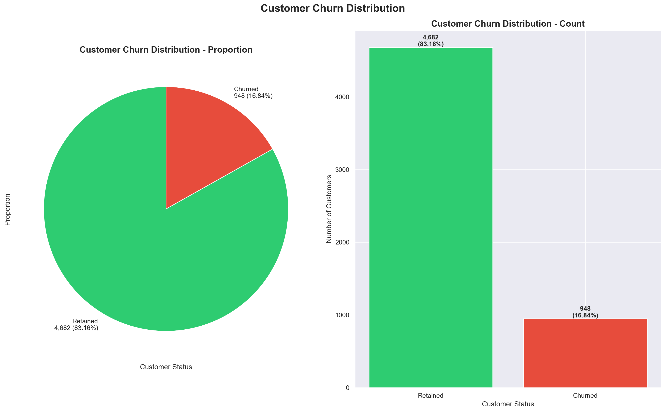
Figure 4 · Customer churn distribution — proportion and count.
The aggregate rate masks concentration: churn is disproportionately located in early lifecycle stages, complaint-making customers and specific preference segments — the basis for targeted retention investment.

6. Churn Driver — Customer Lifecycle
Tenure is the strongest single signal in the data (correlation with churn: −0.34). Churn by lifecycle cohort:
Lifecycle cohort | Customers | Churned | Churn rate
New (0–3m) | 1,560 | 653 | 41.86%
Growing (4–6m) | 590 | 44 | 7.46%
Established (7–12m) | 1,584 | 156 | 9.85%
Mature (13–24m) | 1,467 | 95 | 6.48%
Loyal (25m+) | 429 | 0 | 0.00%

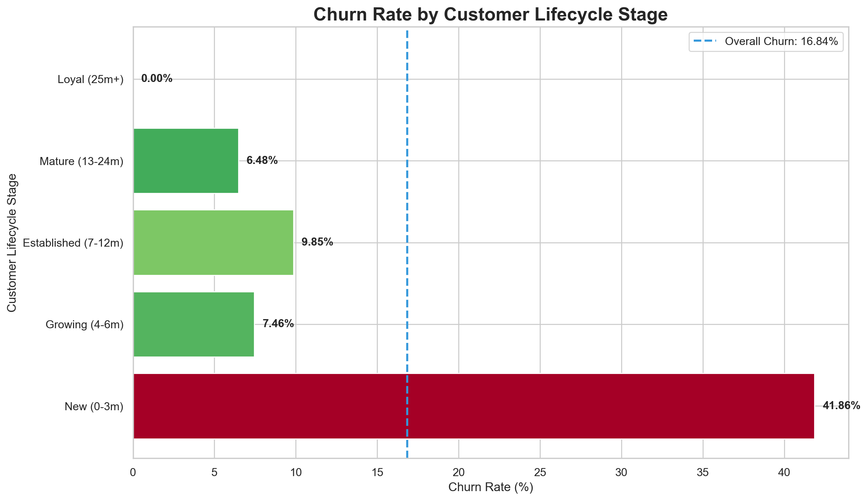
Figure 5 · Churn rate by customer lifecycle stage vs overall rate (16.84%).
The first three months are the highest observed churn-risk stage — 653 of 948 churned customers (≈69%) come from this cohort. Onboarding is the priority retention window.

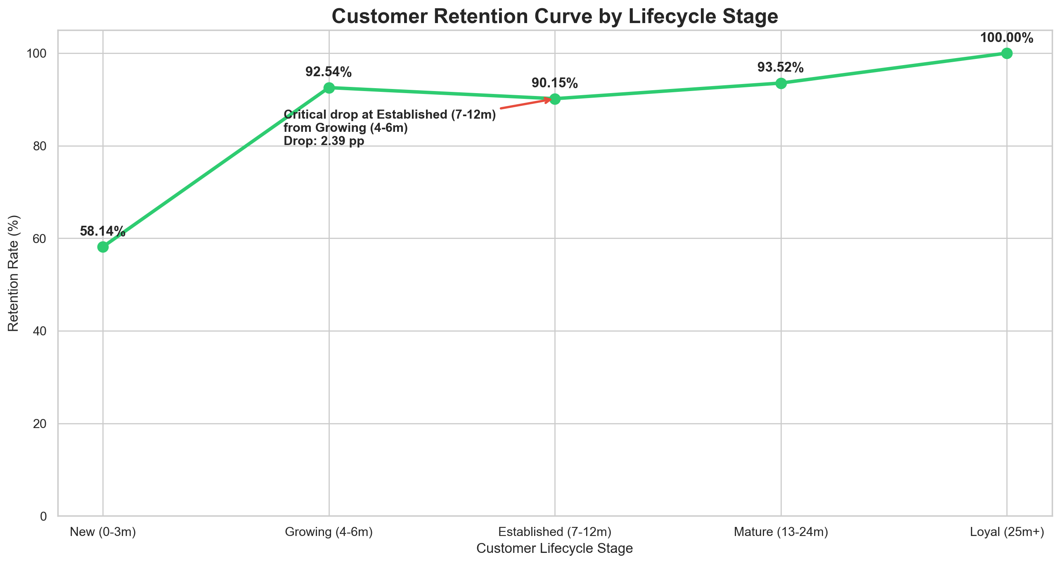
Figure 6 · Retention curve by lifecycle stage; a 2.39 pp dip is observed at the Established stage.

6.1 Lifecycle × city tier
The cohort × city-tier view sharpens targeting: new customers in Tier 2 show the highest observed churn (61.0%), followed by Tier 3 (46.6%) and Tier 1 (38.2%).
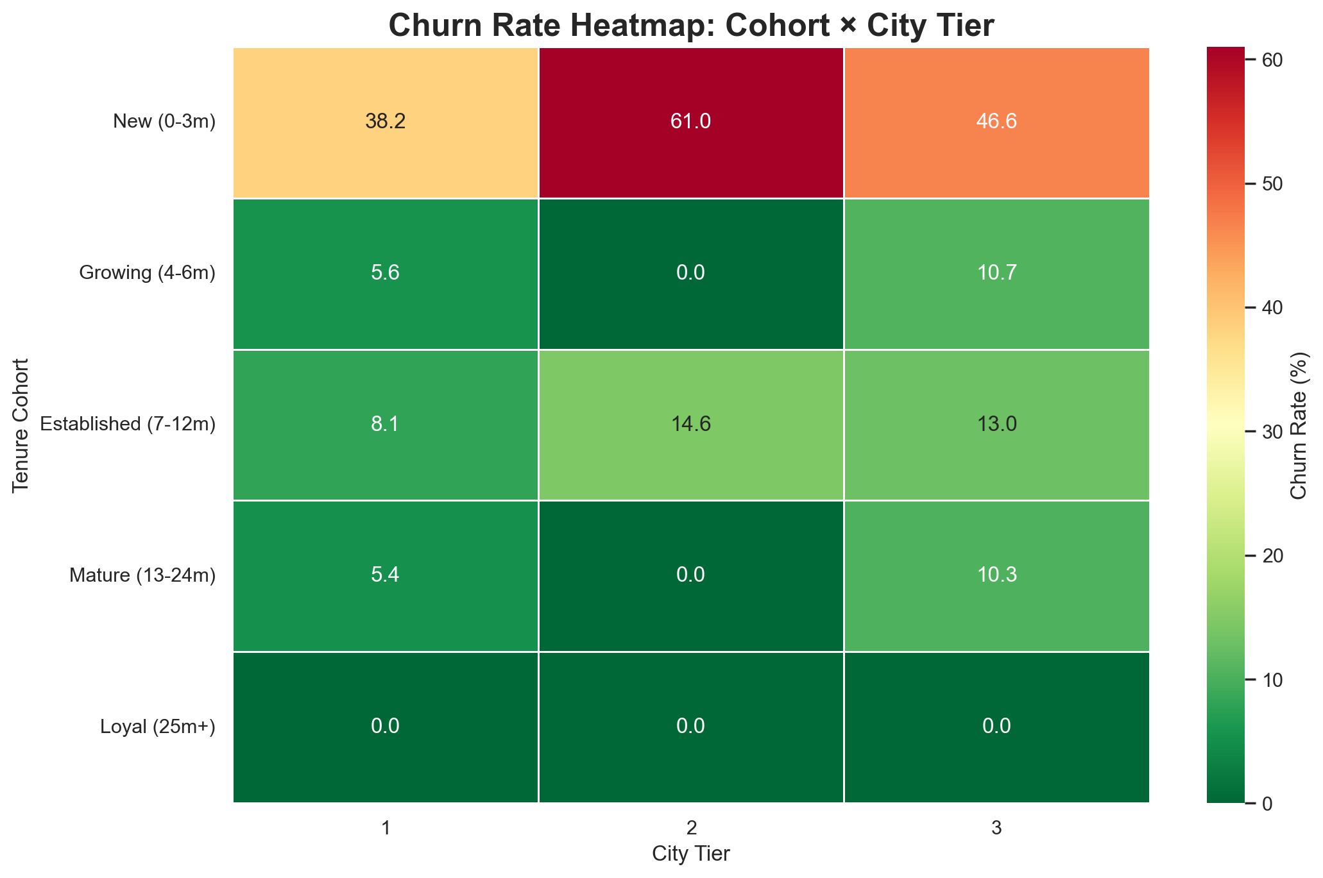
Figure 7 · Churn rate heatmap — tenure cohort × city tier.

7. Churn Driver — Customer Experience

7.1 Complaints
Complaint status | Customers | Churned | Churn rate
Complaint | 1,604 | 508 | 31.67%
No complaint | 4,026 | 440 | 10.93%

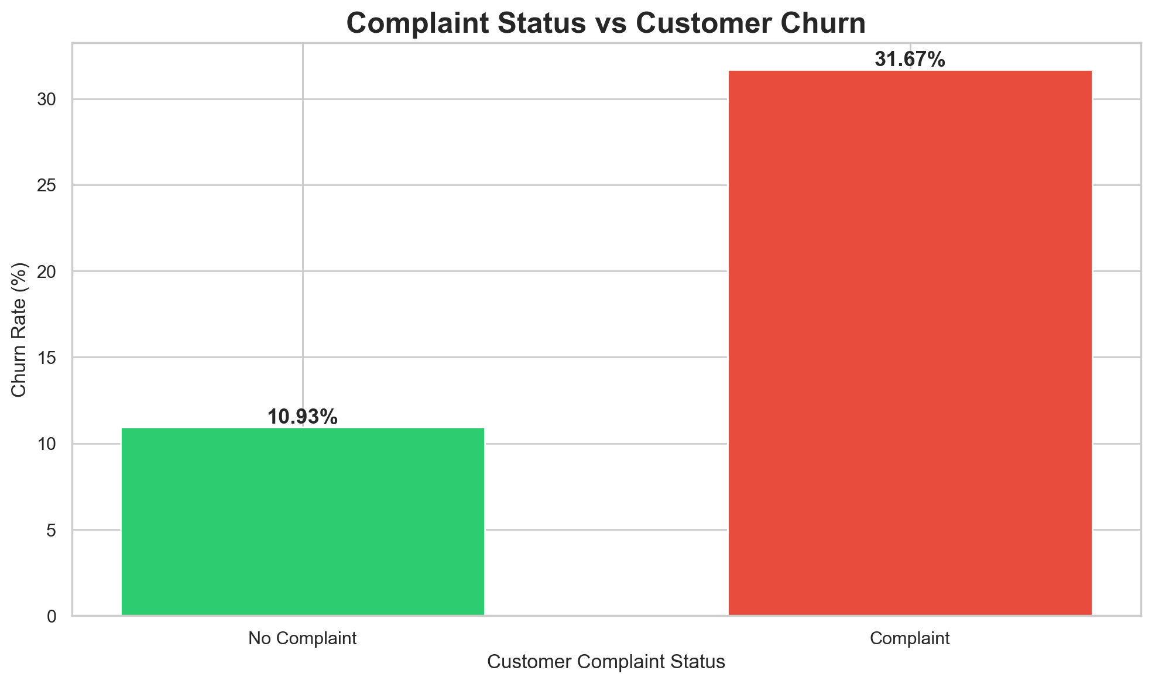
Figure 8 · Churn rate by complaint status — complaint behaviour is strongly associated with churn.
Customers who complained show ≈2.9× the observed churn rate of customers who did not (31.67% vs 10.93%). Complaint handling is a retention intervention opportunity. Reported as association, not causation.

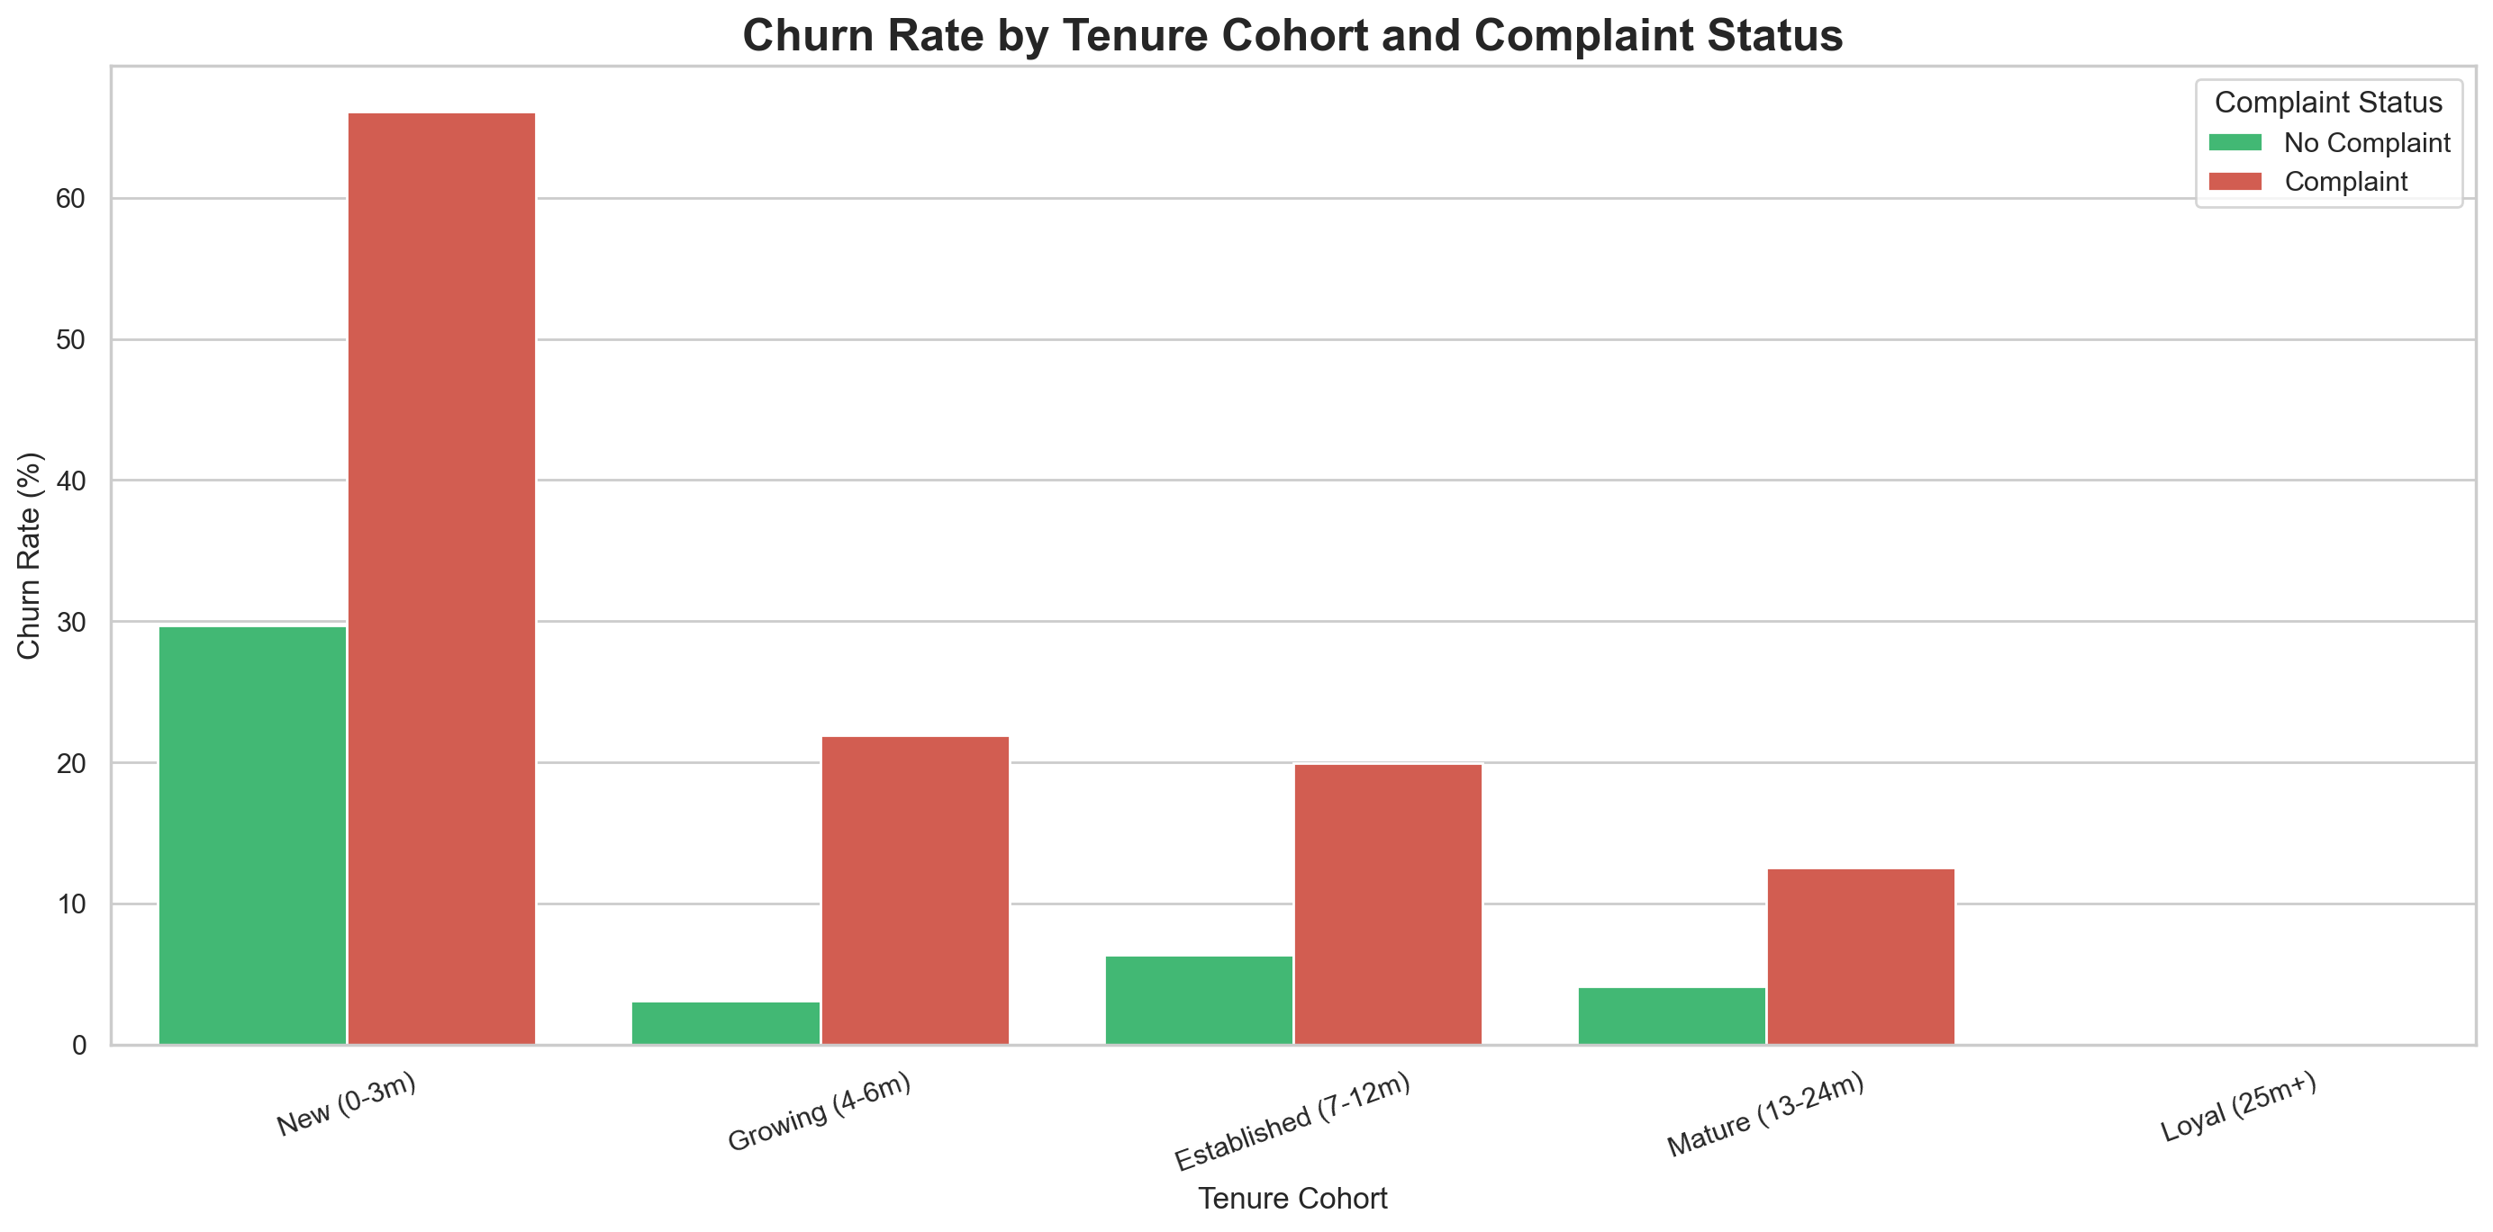
Figure 9 · Churn rate by tenure cohort and complaint status — the complaint gap persists across every lifecycle stage.

7.2 Satisfaction score
Churn by satisfaction score is non-monotonic in this dataset: score-5 customers show the highest observed churn (23.83%), versus 11.51% at score 1. Within the New cohort, churn rises from 30.4% (score 2) to 52.8% (score 5). This pattern warrants a separate service-process review (e.g., when and how satisfaction is captured) before being used as a targeting variable.
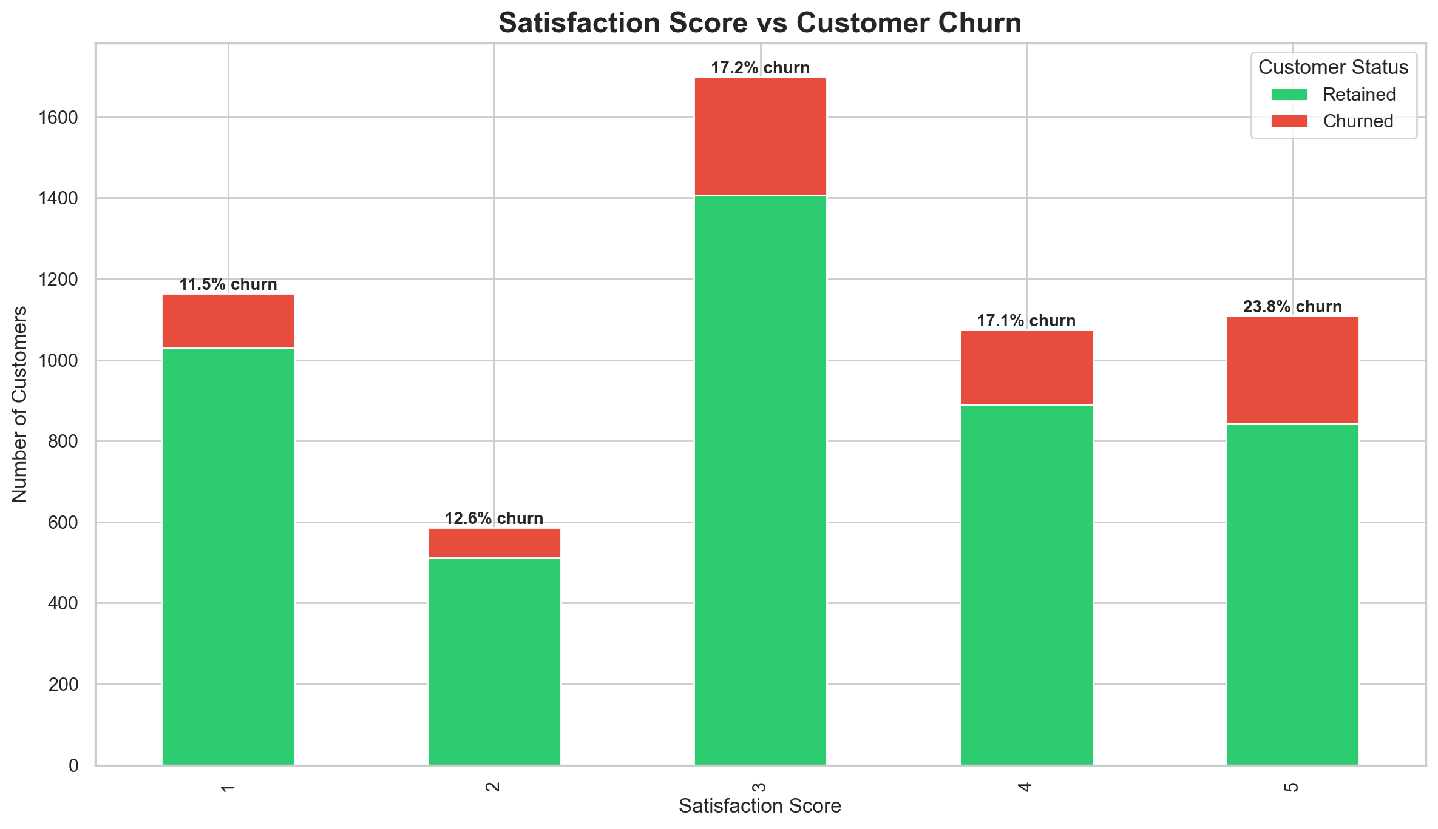
Figure 10 · Satisfaction score vs customer churn.
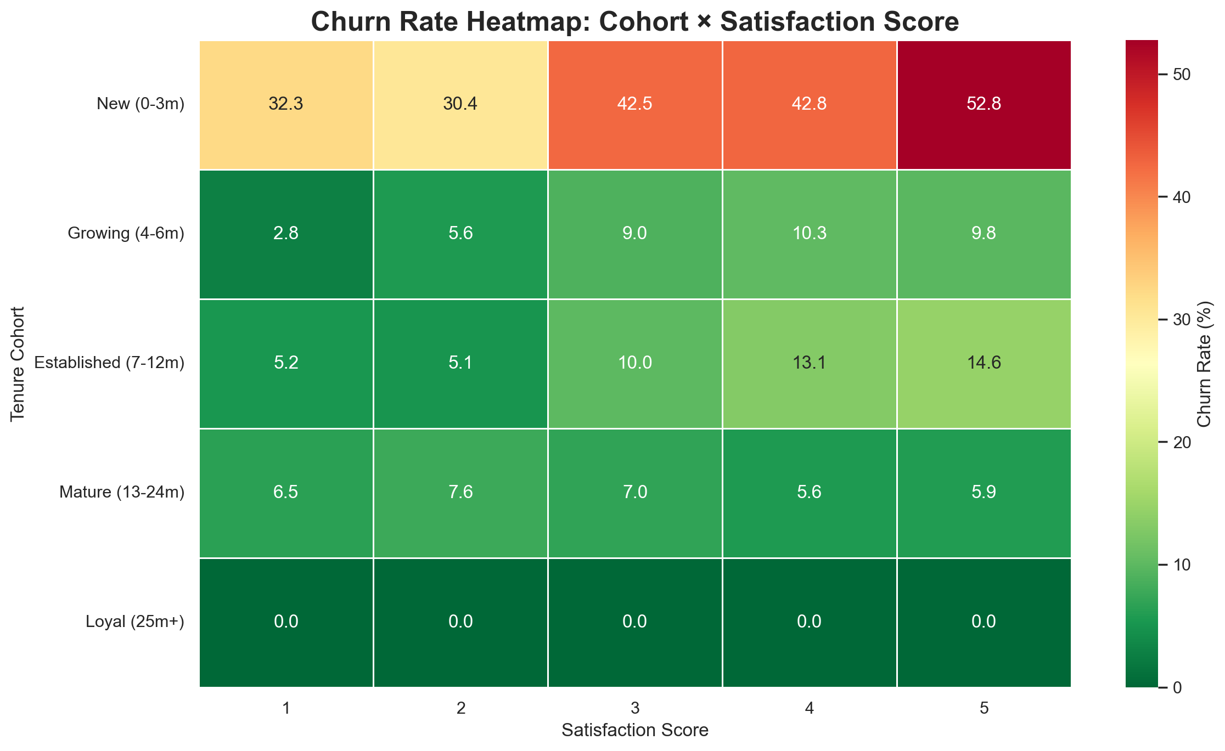
Figure 11 · Churn rate heatmap — tenure cohort × satisfaction score.

8. Other Churn Signals
Churn varies meaningfully across preference and profile dimensions, confirming that risk is multidimensional.

8.1 Payment mode
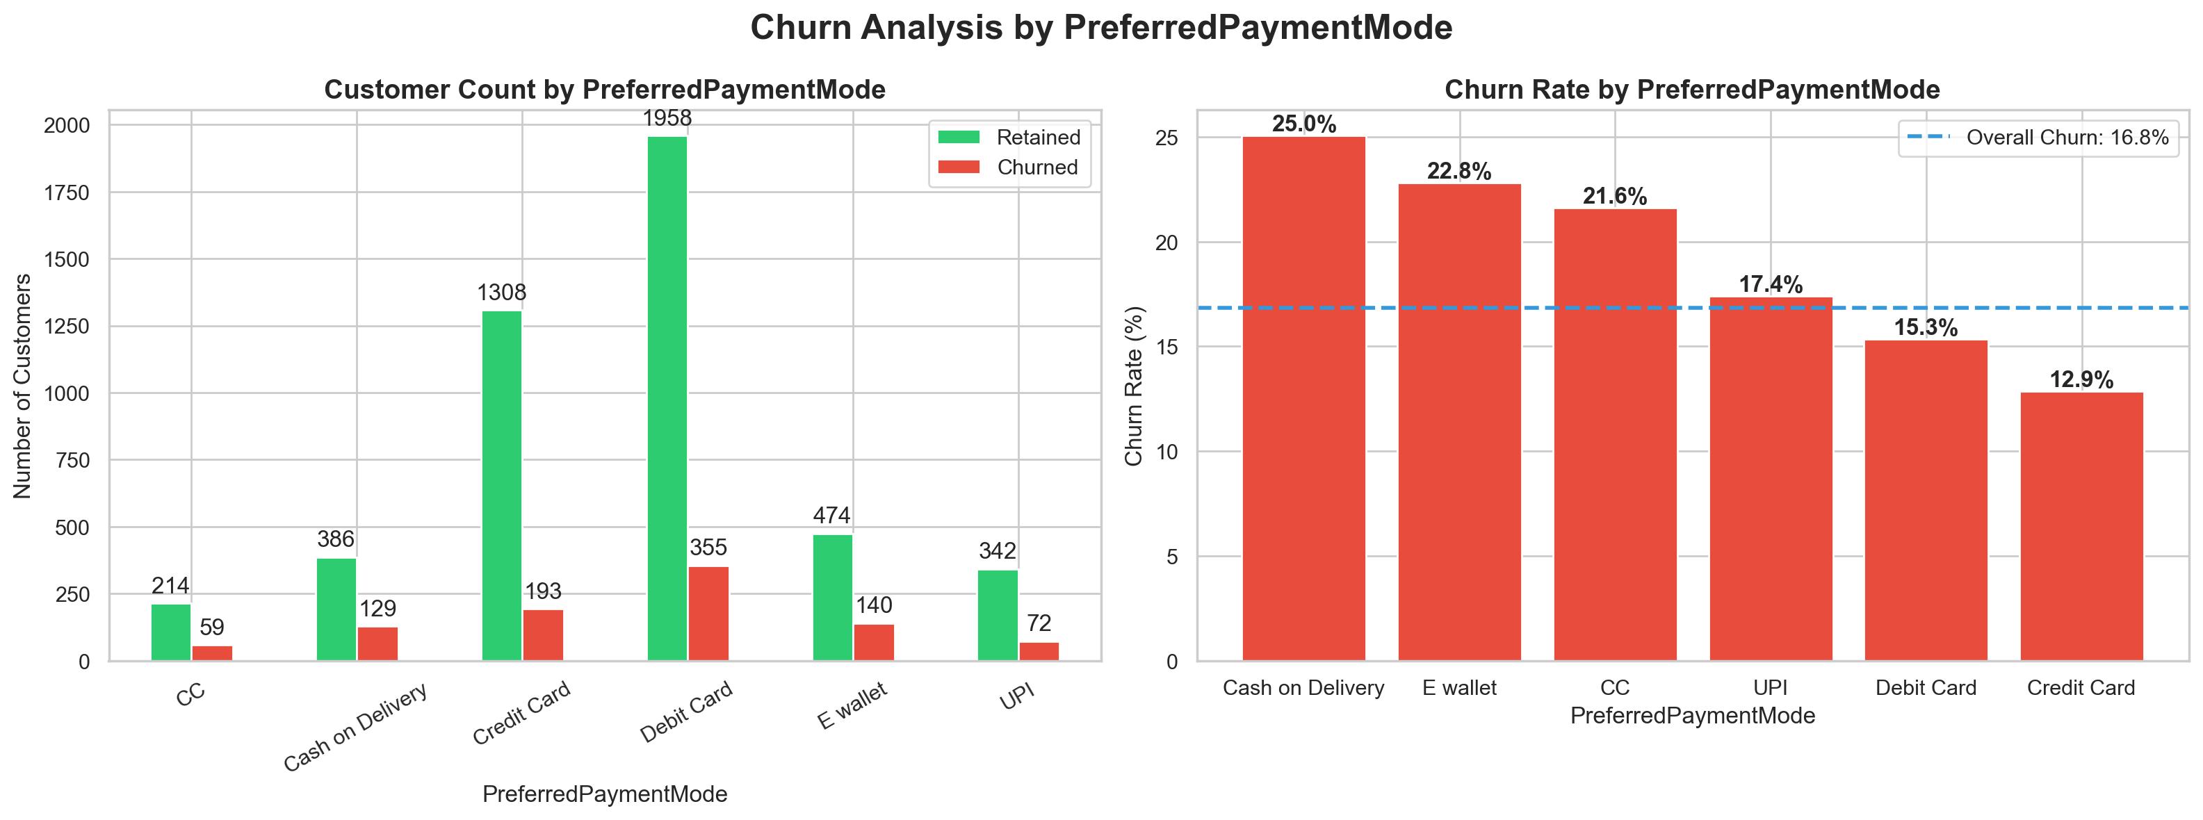
Figure 12 · Churn by preferred payment mode — Cash on Delivery (25.0%) and E-wallet (22.8%) lead; Credit Card (12.9%) is lowest.

8.2 Order category
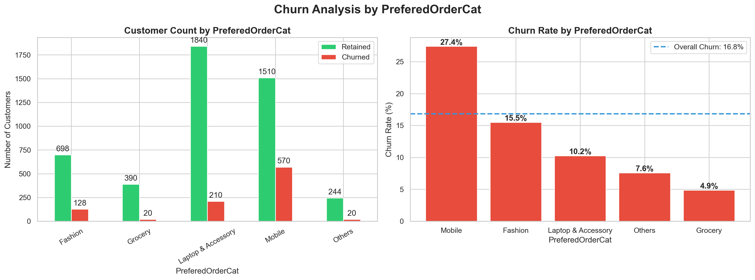
Figure 13 · Churn by preferred order category — Mobile (27.4%) is the highest-risk category; Grocery (4.9%) the lowest.

8.3 Login device
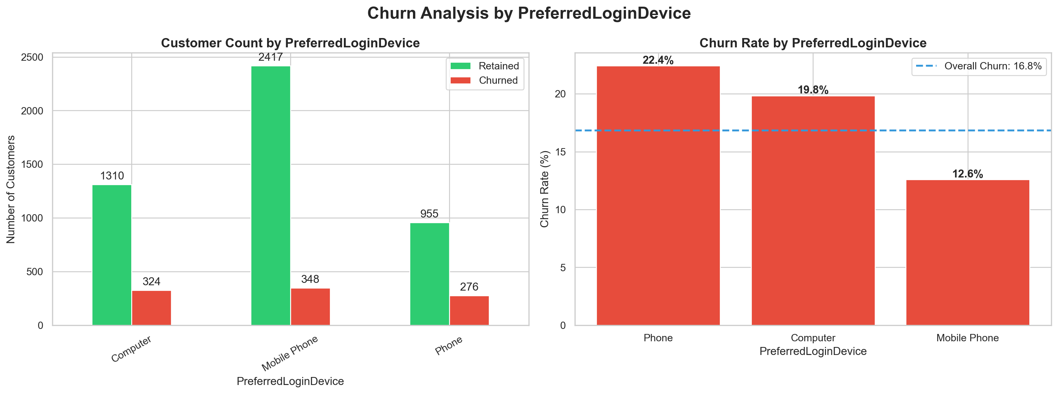
Figure 14 · Churn by preferred login device — Phone-only login (22.4%) vs Mobile Phone (12.6%).

8.4 Gender, marital status & city tier
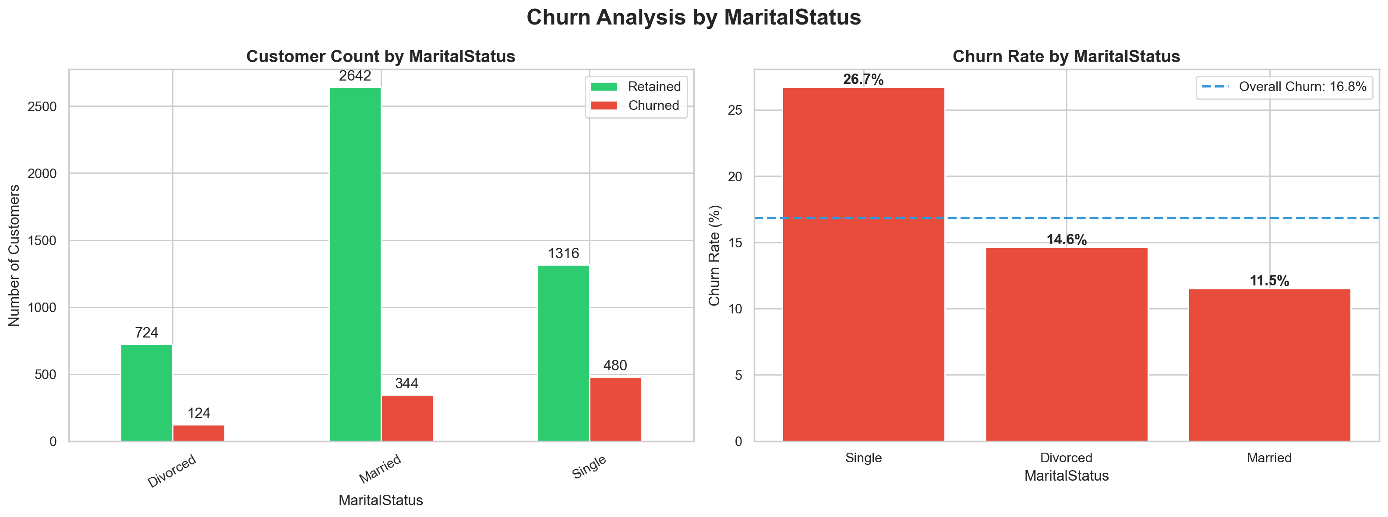
Figure 15 · Churn by marital status — Single customers churn at 26.7% vs Married 11.5%.
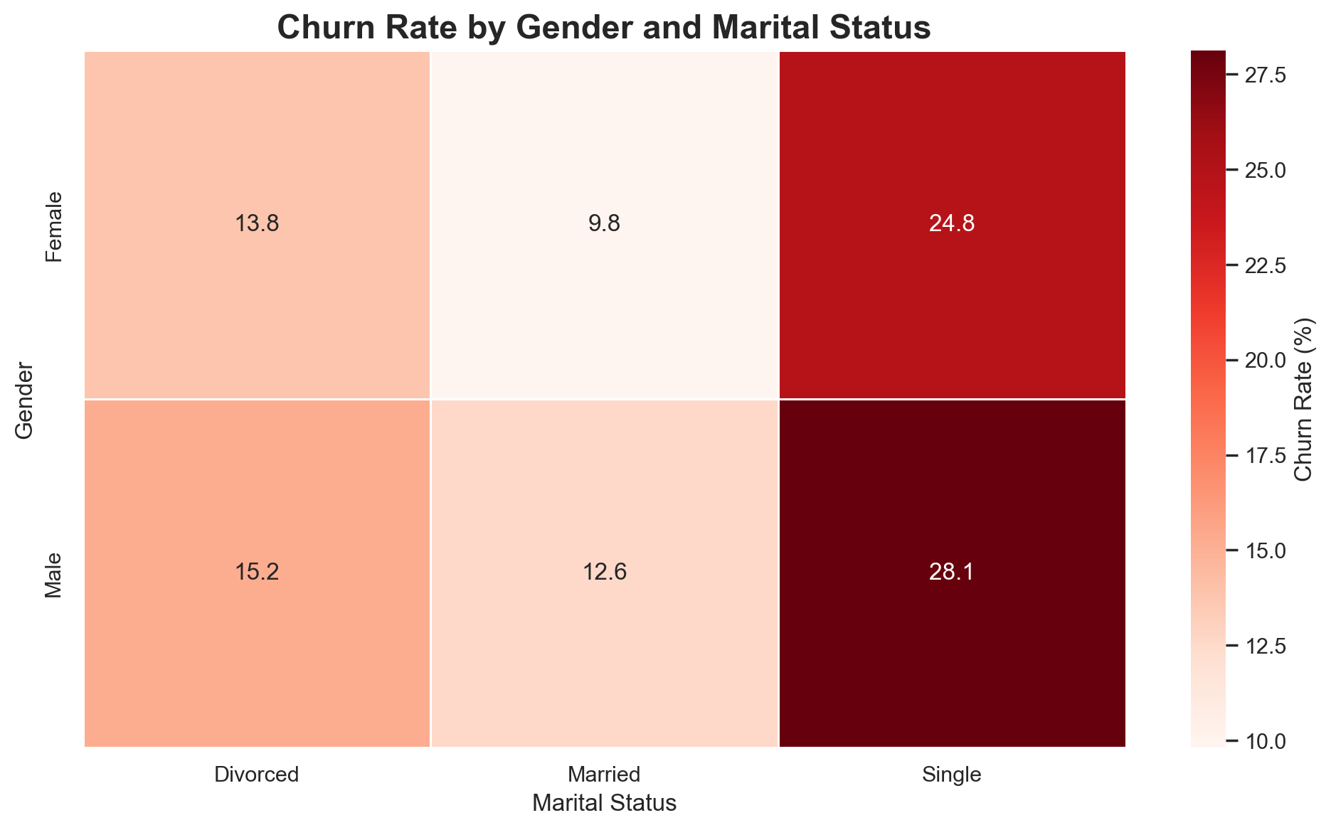
Figure 16 · Churn heatmap — gender × marital status; Single males show the highest observed rate (28.1%).
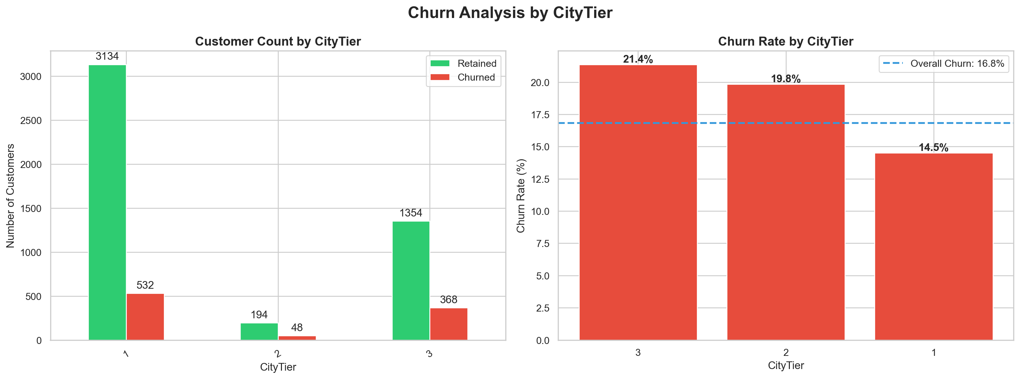
Figure 17 · Churn by city tier — Tier 3 (21.4%) and Tier 2 (19.8%) exceed Tier 1 (14.5%).

8.5 Behavioral distributions (churned vs retained)
Churned customers show markedly shorter tenure (median ≈1 month vs ≈10 months retained) and a lower customer-value proxy distribution, consistent with the lifecycle finding.
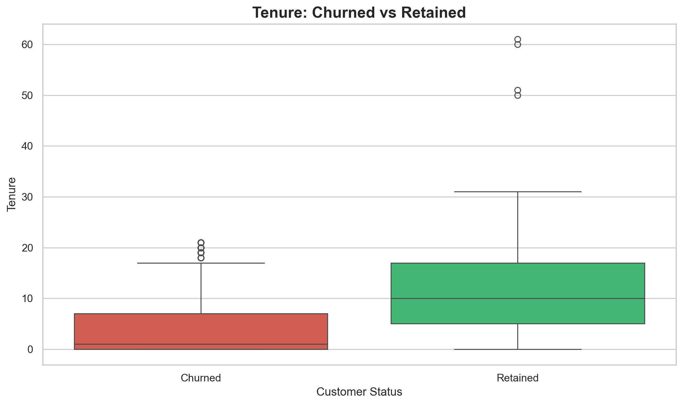
Figure 18 · Tenure distribution — churned vs retained.
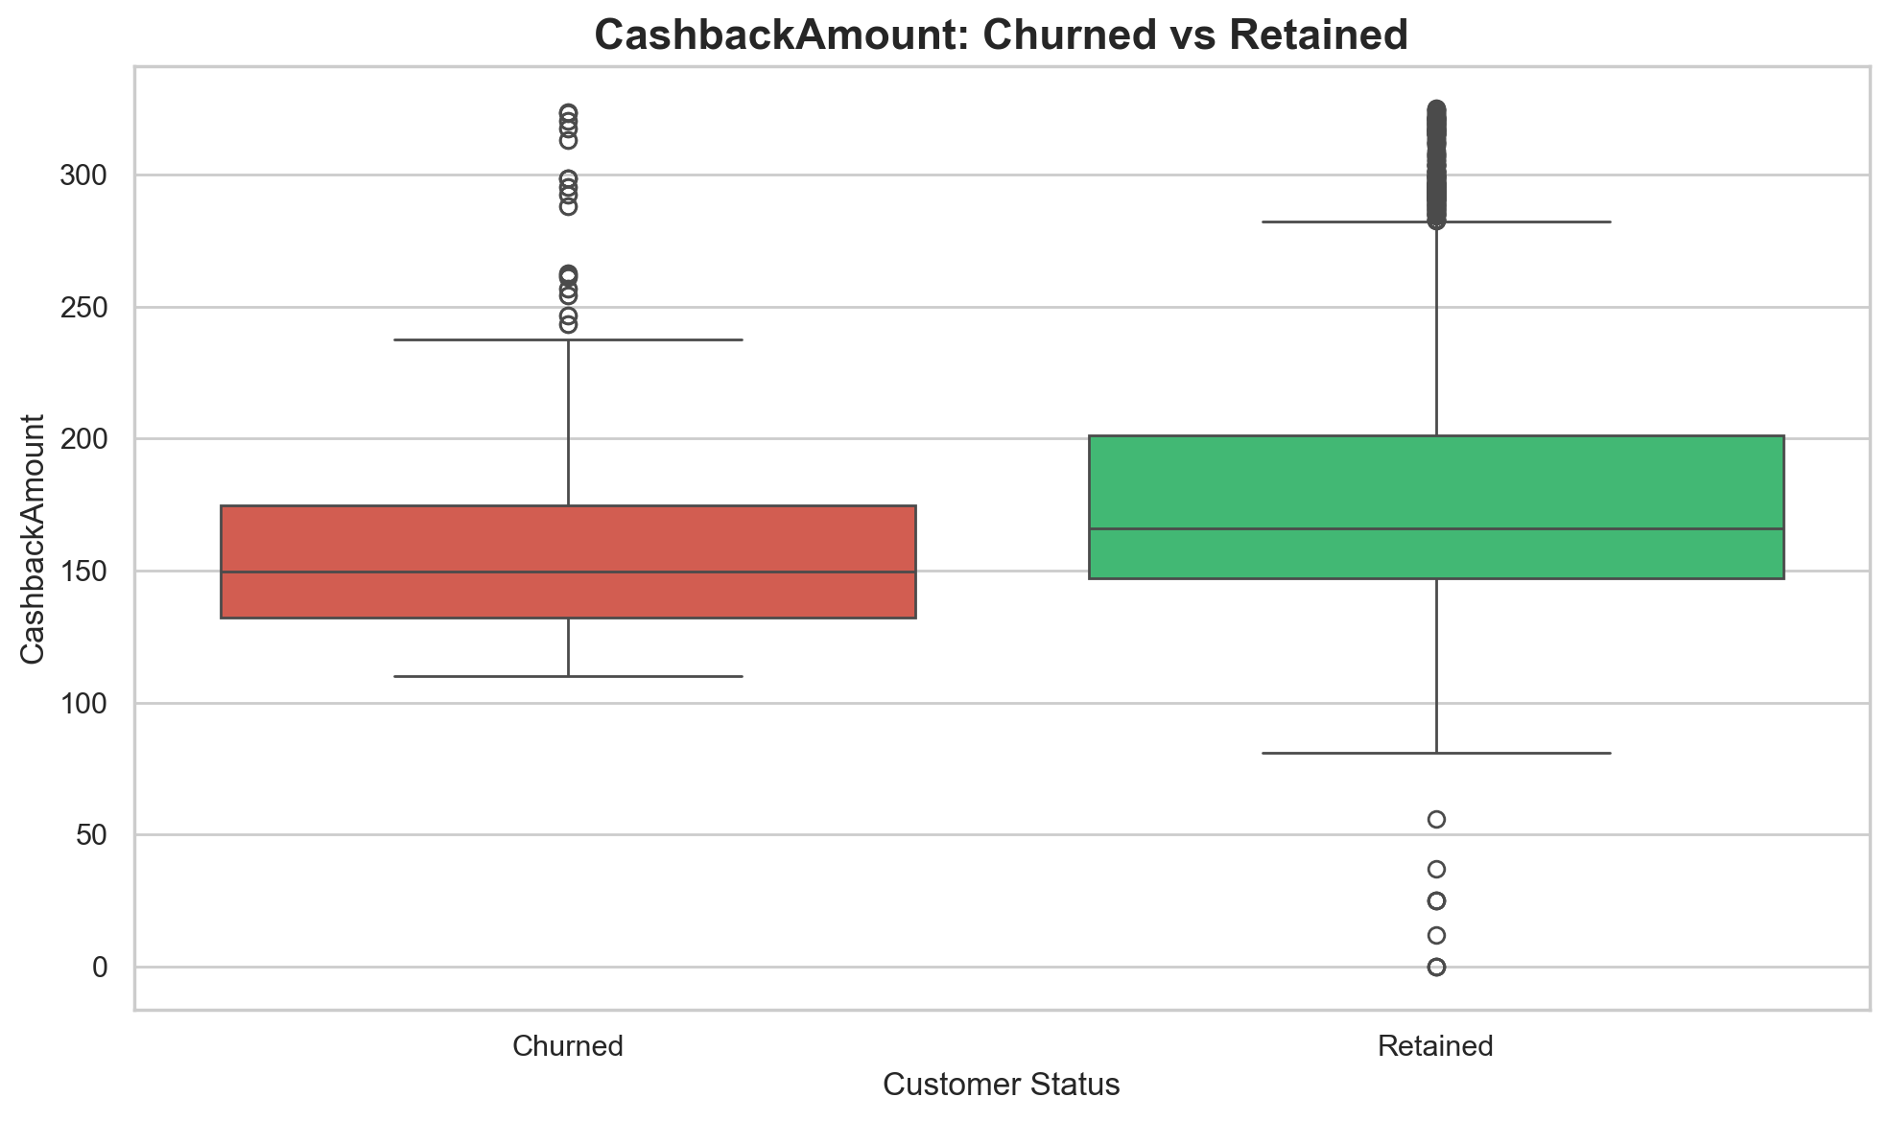
Figure 19 · Customer-value proxy (CashbackAmount) — churned vs retained.

8.6 Numerical association summary
Variable | Correlation with churn | Direction
Tenure | −0.34 | Longer tenure, lower churn (strongest signal)
DaySinceLastOrder | −0.16 | Lower recency association among churned
CashbackAmount | −0.15 | Lower value proxy among churned
NumberOfDeviceRegistered | +0.11 | More devices associated with churn
SatisfactionScore | +0.11 | Non-monotonic; see §7.2

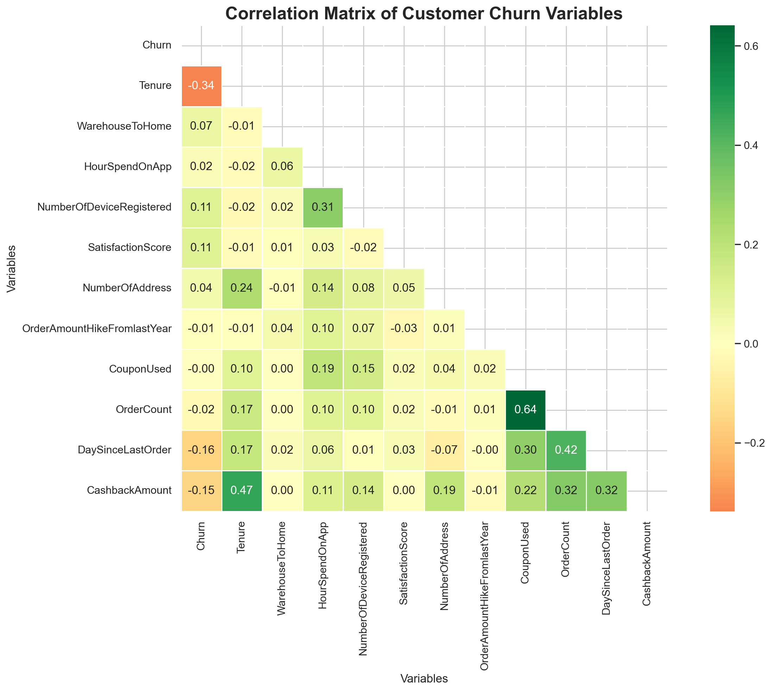
Figure 20 · Correlation matrix of customer churn variables.

9. Customer Value & Risk Segmentation

9.1 Value quartiles (NTILE)
Ranking customers into quartiles on the value proxy shows an inverse risk–value relationship:
Value quartile | Customers | Churn rate | Avg value proxy | Change vs previous quartile
Q1 (lowest) | 1,408 | 25.07% | 130.09 | —
Q2 | 1,408 | 19.82% | 153.00 | −5.25 pp
Q3 | 1,407 | 11.51% | 177.22 | −8.31 pp
Q4 (highest) | 1,407 | 10.95% | 248.63 | −0.56 pp

9.2 RFM segmentation
RFM segment | Customers | Observed churn rate
Champions | 0 | — (no customers in this dataset)
Loyal Customers | 284 | 15.49%
Potential Loyalists | 2,018 | 16.40%
At Risk | 2,723 | 17.66%
Lost Customers | 605 | 15.21%

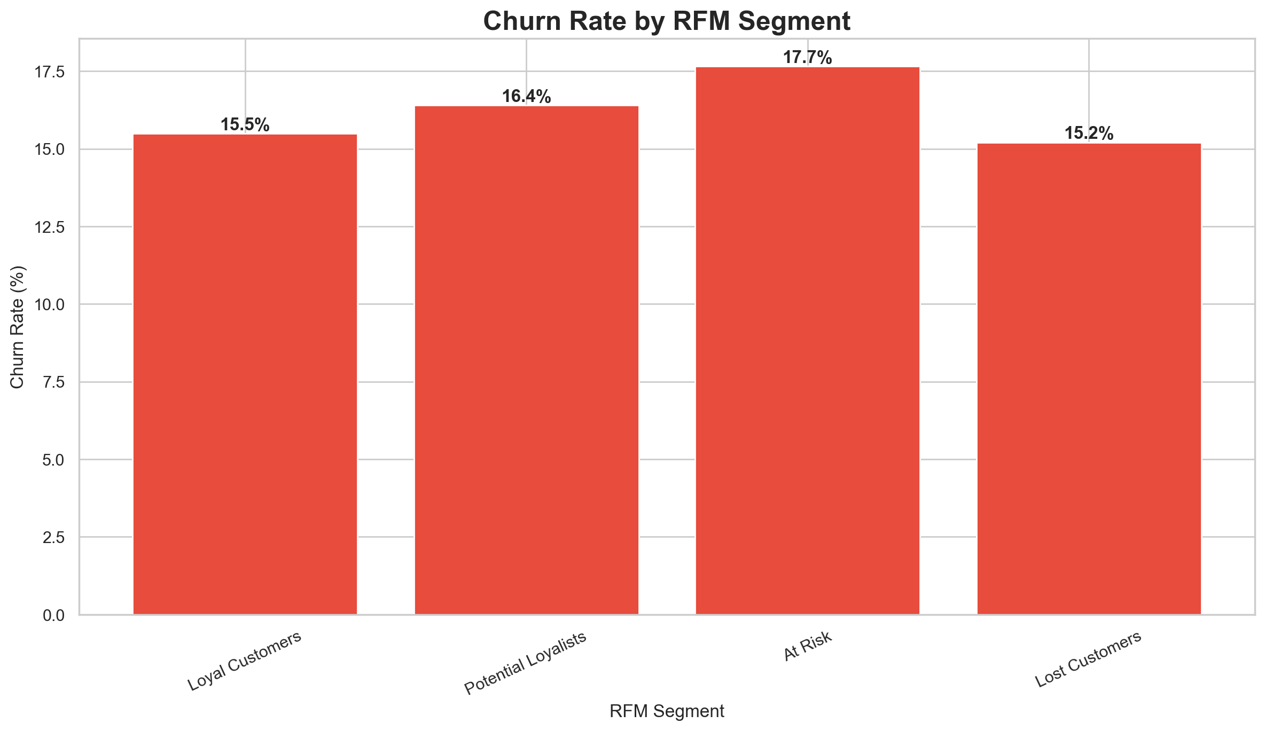
Figure 21 · Churn rate by RFM segment (notebook output).

9.3 Risk-level segmentation
Risk level | Customers | Churn rate | Value proxy at risk
Critical risk | 166 | 60.2% | ₹25,632
High risk | 1 | 100.0% | ₹206
Medium risk | 215 | 3.7% | ₹36,404
Low risk | 545 | 0.9% | ₹115,599
Standard risk | 4,703 | 17.7% | ₹819,925

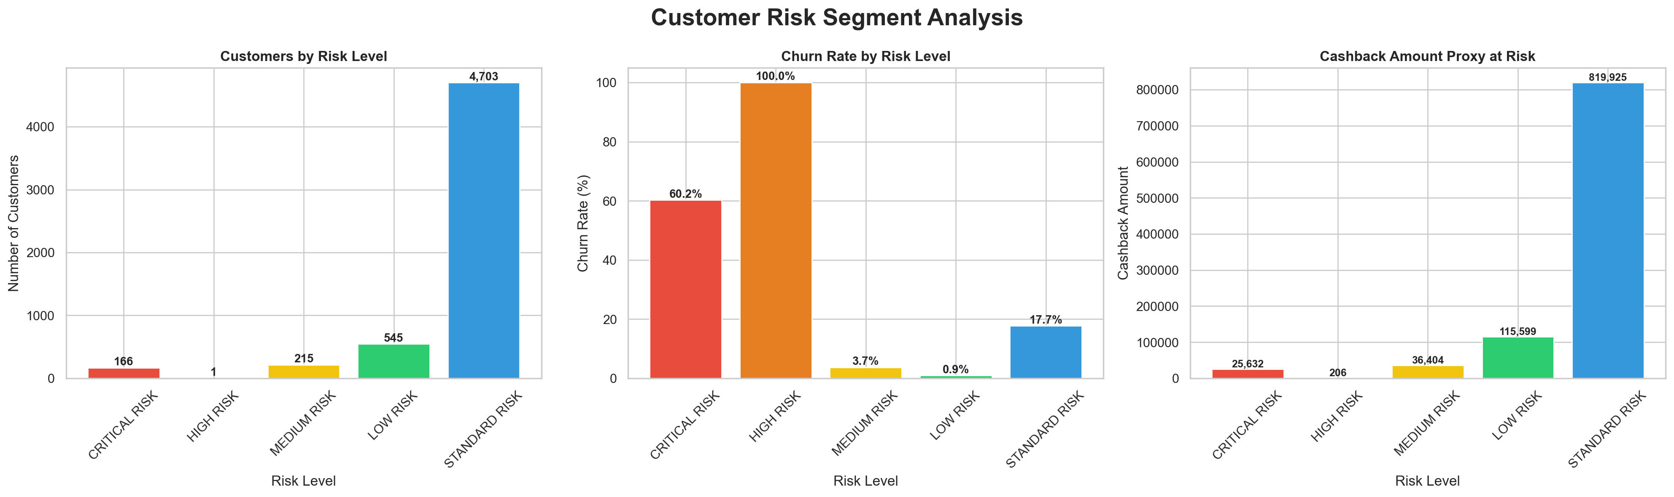
Figure 22 · Customer risk segment analysis — counts, churn rates and value proxy at risk.
The critical + high risk pools (167 customers) carry ₹25,838 of currently exposed customer-value proxy — a compact, high-yield target list for human-led retention.

9.4 Value concentration
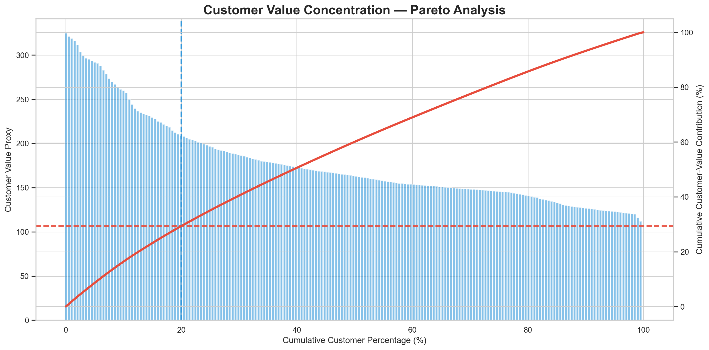
Figure 23 · Pareto analysis of customer-value proxy — the top ~20% of customers contribute roughly ~30% of proxy value.

9.5 Prioritization logic
Quadrant | Recommended stance
High value + high risk | Priority retention — proactive, human-led saves
High value + low risk | Loyalty / protection — milestone rewards
Low value + high risk | Automated / low-cost retention — triggered offers
Low value + low risk | Standard engagement — business-as-usual

10. Business Impact — Value at Risk
Churn converts into measurable customer-value exposure. All figures below are CashbackAmount-derived customer-value proxy, not actual revenue.
Metric | Value
Total customer-value proxy | ₹997.77K
Value associated with churn | ₹152.03K (15.24% of proxy)
Value currently at risk (critical + high risk) | ₹25,838
Potential protected value at 5% churn reduction | ₹7.60K
Potential protected value at 10% churn reduction | ₹15.20K

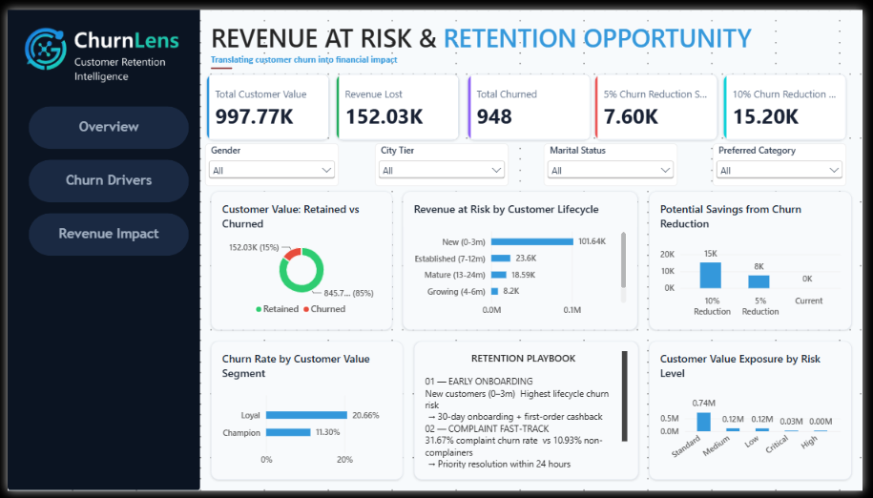
Figure 24 · ChurnLens Revenue Impact dashboard — value at risk and retention opportunity.
Value at risk is lifecycle-concentrated: New customers carry ₹101.64K of the churn-associated value, versus ₹23.6K (Established), ₹18.59K (Mature) and ₹8.2K (Growing). Protecting early-lifecycle retention therefore protects the largest share of exposed value.
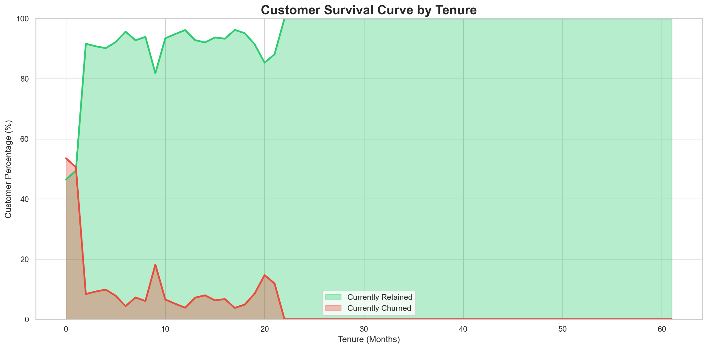
Figure 25 · Survival-style curve — the churn share is concentrated in the first tenure months and approaches zero beyond ~22 months.
Guardrail: all monetary figures are CashbackAmount-derived customer-value proxy — not actual company revenue.

11. Retention Strategy & Action Plan

11.1 Where to intervene
Priority | Target segment | Evidence | Rationale
P1 | New customers (0–3m) | 41.86% churn; 653 of 948 churned; ₹101.64K value at risk | Highest lifecycle risk and largest value exposure
P2 | Customers with complaints | 31.67% vs 10.93% (≈2.9×) | Service recovery is a retention intervention
P3 | At-Risk / Lost & critical-risk segments | 17.66% / 15.21% RFM; critical pool 60.2% | Compact, high-yield target lists
P4 | Growing / mid-tenure | 7.46% today; −2.39 pp retention dip at Established | Prevent migration into higher-risk states

11.2 Retention playbook
Intervention | Target | Design
01 — Early onboarding | New customers (0–3m) | 30-day onboarding journey; first-order engagement / cashback intervention
02 — Complaint fast-track | Customers who complain | Priority resolution (≤24h) plus structured follow-up after resolution
03 — Loyalty / milestone engagement | Growing / mid-tenure | 6-month and 12-month milestone rewards to defend the Established-stage dip

11.3 90-day operating roadmap
Phase | Actions
0–30 days | Identify new-customer risk pool · establish complaint fast-track · create churn-risk monitoring view
31–60 days | Launch onboarding intervention · introduce service-recovery follow-up · monitor high-risk segments
61–90 days | Evaluate outcomes · compare churn before/after · refine segments · scale successful interventions

11.4 KPIs to monitor
Churn rate · Retention rate · Complaint churn rate · New-customer churn · At-risk customer count · Customer-value exposure. Review cadence: monthly retention review with Customer Success, CRM and Marketing.

12. Conclusions & Recommendations
- Churn is concentrated: early-lifecycle customers churn at 41.86% while later stages stay below 10% (Loyal 0.00%).
- Customer experience matters: complaint behaviour is strongly associated with higher churn (31.67% vs 10.93%).
- Value changes priority: risk-level and value-quartile segmentation convert churn statistics into target lists and exposure figures.
- Retention has a measurable business case: reducing churn protects part of the ₹152.03K customer-value exposure (₹7.60K per 5 pp; ₹15.20K per 10 pp).
Recommended focus: prevent early churn → resolve complaints faster → protect high-risk customer value.

13. Limitations & Guardrails
- CashbackAmount is a monetary proxy for customer value; figures are not actual company revenue.
- All relationships are observed associations; no causal claims are made.
- No predictive model was built; no model performance metrics are claimed.
- The satisfaction–churn relationship is non-monotonic and requires process review before operational use.
- The Champions RFM segment contains 0 customers in this dataset; RFM definitions should be revisited as the base matures.
- Scenario savings (5%/10% reductions) are potential, not guaranteed, outcomes.

Appendix A — Technical Implementation

A.1 Python
Pandas · NumPy for cleaning and transformation; null profiling (isnull().sum()), duplicate detection (duplicated().sum()), median imputation; Matplotlib/Seaborn for EDA, cohort and heatmap visuals; RFM and cohort construction for segmentation.

A.2 SQL (MySQL 8.0+)
Representative constructs used across the business-query layer:
WITH tenure_segments AS (
SELECT CASE WHEN Tenure <= 3 THEN 'New (0-3m)' ...
FROM ecommerce_churn )
NTILE(4) OVER (ORDER BY CashbackAmount) AS value_quartile
RANK() OVER (ORDER BY CashbackAmount DESC) AS value_rank
SUM(CASE WHEN Churn = 1 THEN 1 ELSE 0 END) ... LAG() OVER (ORDER BY Tenure)

A.3 Power BI
Three dashboard pages — Overview, Churn Drivers, Revenue Impact — with KPI cards, slicers (gender, city tier, marital status, preferred category) and the retention playbook panel for management consumption.
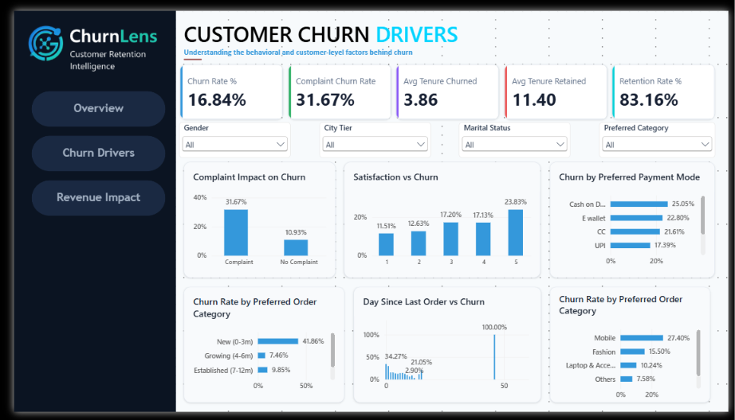
Figure 26 · ChurnLens Drivers dashboard.

A.4 Architecture
Raw Excel → Python data preparation → clean CSV → MySQL analytical database → business SQL layer → customer risk / business metrics → Power BI dashboards → management decision. End-to-end ownership by a single analyst pipeline.

Appendix B — Figure & Data Source Index
All figures are reproduced from the project's validated analytical outputs (Python/Seaborn charts, MySQL query results and Power BI dashboards). Underlying data files: ecommerce_churn_raw.xlsx, cleaned_ecommerce_churn.csv, customer_risk_segments.csv, final_business_metrics.csv; SQL scripts 01_database_setup.sql, 02_data_cleaning.sql, 03_business_queries.sql; and the project notebooks.
- B.1 ChurnLens dashboards (Overview / Drivers / Revenue Impact) — Power BI exports
- B.2 Missing values by column; churn distribution
- B.3 Lifecycle churn, retention curve, cohort × city-tier heatmap
- B.4 Complaint & satisfaction visuals, cohort heatmaps
- B.5 Segment charts: payment, category, login device, marital, city tier, gender × marital
- B.6 Boxplots (tenure, value proxy), correlation matrix
- B.7 RFM, risk segments, Pareto value concentration
- B.8 Intelligence dashboard composite
— End of report —

